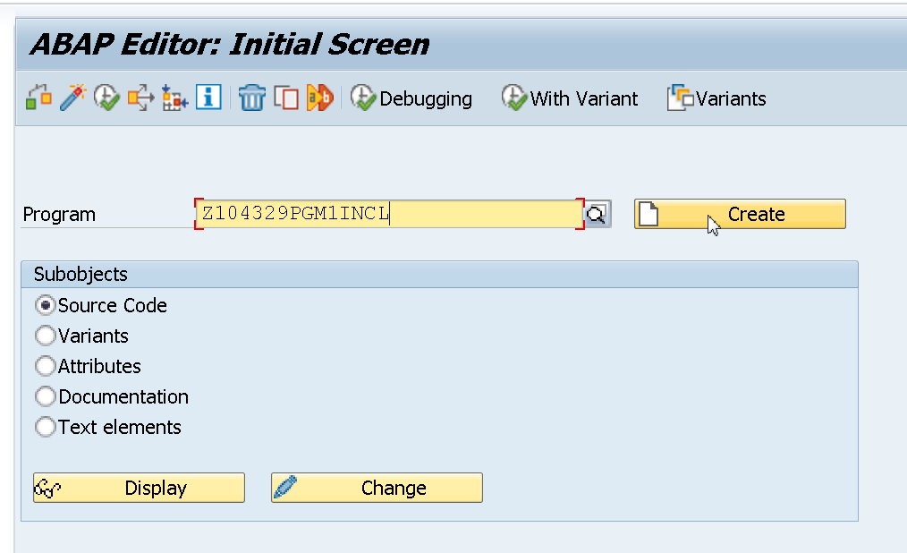

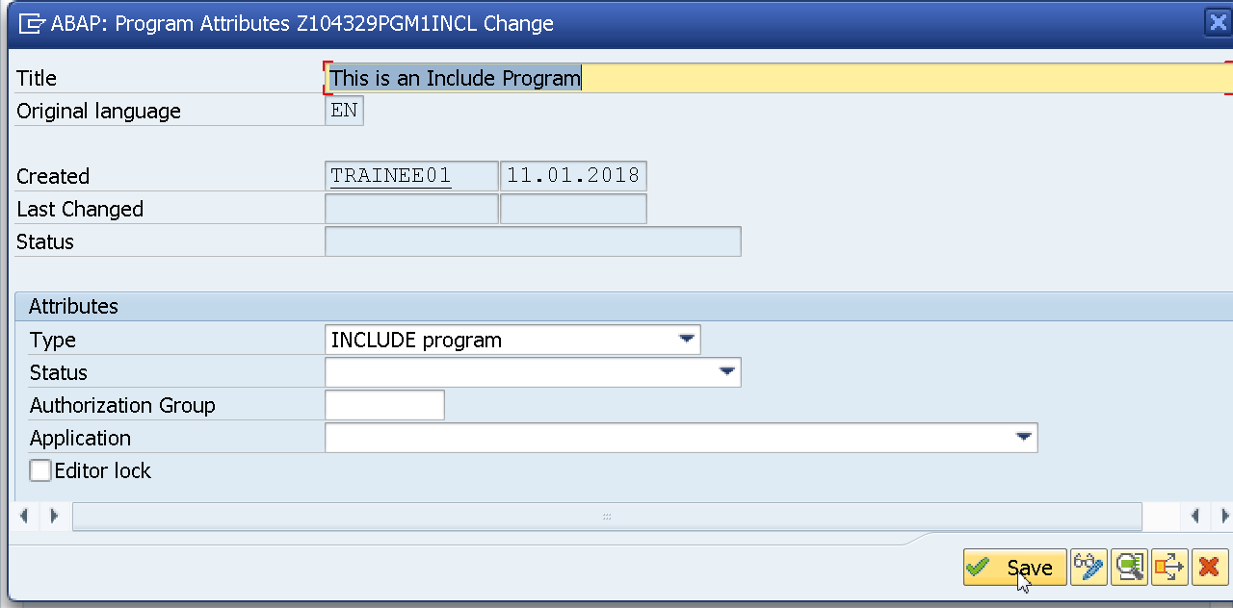

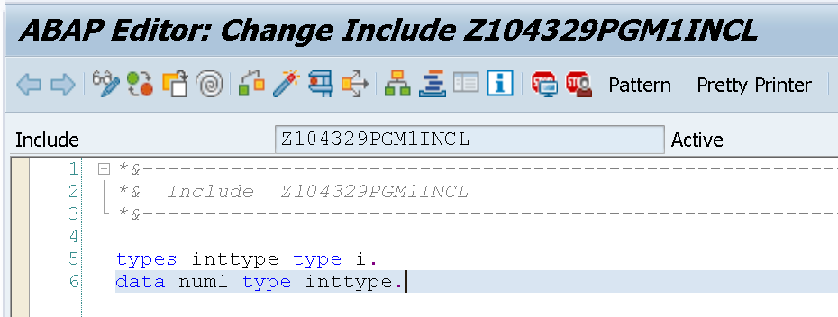

types inttype type i.  
data num1 type inttype.

Now create an Executable program in SE38.

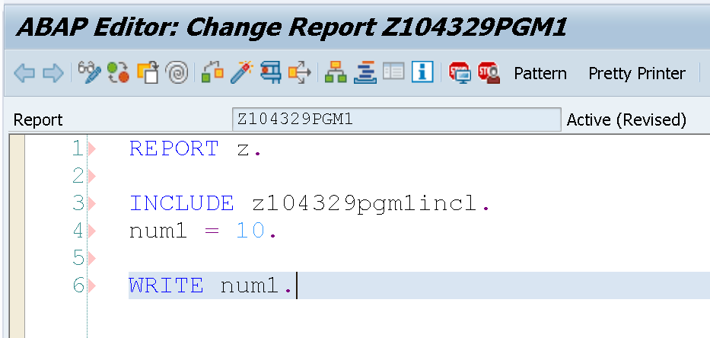

REPORT Z.  
INCLUDE Z104329PGM1INCL.  
NUM1 = 10.  
WRITE NUM1.